**c# program that receive alarms from tradingview**

I need a c# program that receive alarms from tradingview.

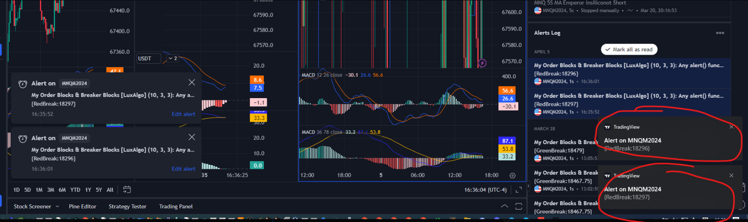

1. the program receives the alarms and save in alarm.txt and clear the alarms.
2. and you should clear these alarms.

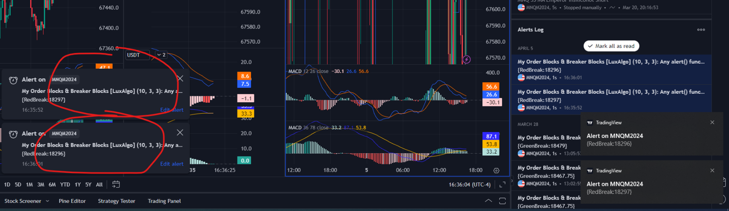

continue repeating 2 stage.

Time: 1 day

Budget: $100 (paypal, payoneer, trc20)

Before payment, you should send me the exe.

After I check the exe, I’ll pay

After payment, you send me the source code.